1. Pr(Issac answering a question correctly) = 1/4

If X is random variable represents the number of questions he answered correctly then

Pr(Issac answering at least 4 of the questions correctly)

= P(X >= 4)

= P(X = 4) + P(X=5)

= 5C4 * (1/4)4 * 3/4 + 5C5 * (1/4)5

= 1/64

1. Mutually exclusive events mean if one event happens then there is no chance for another event to happen. If A and B are mutually exclusive then P(A ^ B) = 0 and P(A) + P(B) = 1.

For the given events in problem with probabilities Pr(A) = 0.6 and Pr(B) = 0.8, these conditions won’t satisfy, so these two are not mutually exclusive.

1. E(profit) = Premium paid * P(person survives) - Insurance claim * P(person passes away)

= 15,000 * 0.9986 - 1,00,00,000 * 0.0014

= 14979 – 14000

= 979

1. If events A and B are (pairwise) independent and B and C (pairwise) independent then we can’t really conclude anything about A and C events independence, they could be either independent or dependent.

For example, consider three below random variables and the events A, B and C represents the variables taking value as 1.

|  |  |  |
| --- | --- | --- |
| X1 | X2 | X3= X1 ^ X2 |
| 0 | 0 | 0 |
| 1 | 0 | 1 |
| 0 | 1 | 1 |
| 1 | 1 | 0 |

Here, X1 and X2 are independent and X2 and X3 are independent so are X1 and X3.

We can prove that by calculating

P(A and B) = P([X1 and X2]=1) = P(X1=1)P(X2=1) = ¼

P(B and C) = P([X2 and X3]=1) = P(X2=1)P(X2=1) = ¼ and also

P(A and C0 = P([X1 and X3]=1)= P(X1=1)P(X3=1) = ¼

By taking another example, we can prove the opposite too that is if A and B, B and C are pairwise independent then A and C can be dependent.

For example, if A represents the event “India wins the world cup” and B represents the event “Pakistan wins the world cup” and C represents the “Virat Kohli takes man of series” then we can say A and B, B and C are pairwise independent but A and C are necessarily are independent.

Because C event happening can change the A event probability.

1. According to reservoir sampling algorithm, to maintain random sample of k length out of stream n numbers, we pick the nth number with k/n probability and do nothing with n-k/n probability.

In the given problem we maintain 11 random players, so when 21st player comes we chose him with chance of 11/21 and do nothing with 10/21.

To include or not we can generate a random number from 1 to 21, if we get a number between 1 to 11, then player in that position is replaced with 21st player otherwise we’ll exclude him.

1. We are seeing a stream of size m with numbers ranging from [1-n]. For calculating space for arithmetic mean of the stream we need two values 1) Sum of the stream 2) Count of the stream

For sum of the stream we can maintain a cumulative sum in memory and update whenever we see a number. But this number can be in range [1-n], so in the extreme case we may get all the m numbers in the upper range of [1-n] because there is no underlying distribution guaranteed.

So, if m numbers are there with each number in O(n) then sum of those numbers will be O(mn).

To store this number we need O(log(mn)) = O(logm) + O(logn) bits.

In second part, we need count of the stream, if we use Morris algorithm, then we can get this in

O(loglogm) space.

So, total space complexity will be O(logm) + O(logn) + O(loglogm) = O(logm) + O(logn)

1. Solution is Attached below in pic.

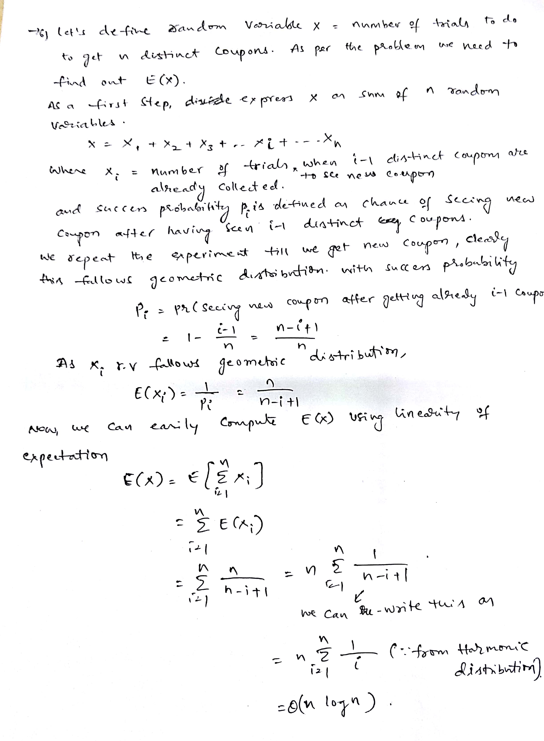

1. Let X = face value of die

E(X) = 3.5

Var(X) = 2.9167

If Z = sum of 100 independent dice rolls

E(Z) = 100 * 3.5 = 350

Var(Z) = 100 * 2.9167 = 291.67

Using Chebyshev’s inequality , we can say

P(|Z-E(Z)| > c) <= Var(Z)/ c2

P(|Z-350| > 50) <= 291.67/50*50 = 0.117

1. Answer attached :

Correction in below attachment

Pr(None of m keys mapped to 1) = 1- Pr(Atleast one of the m keys mapped to 1)

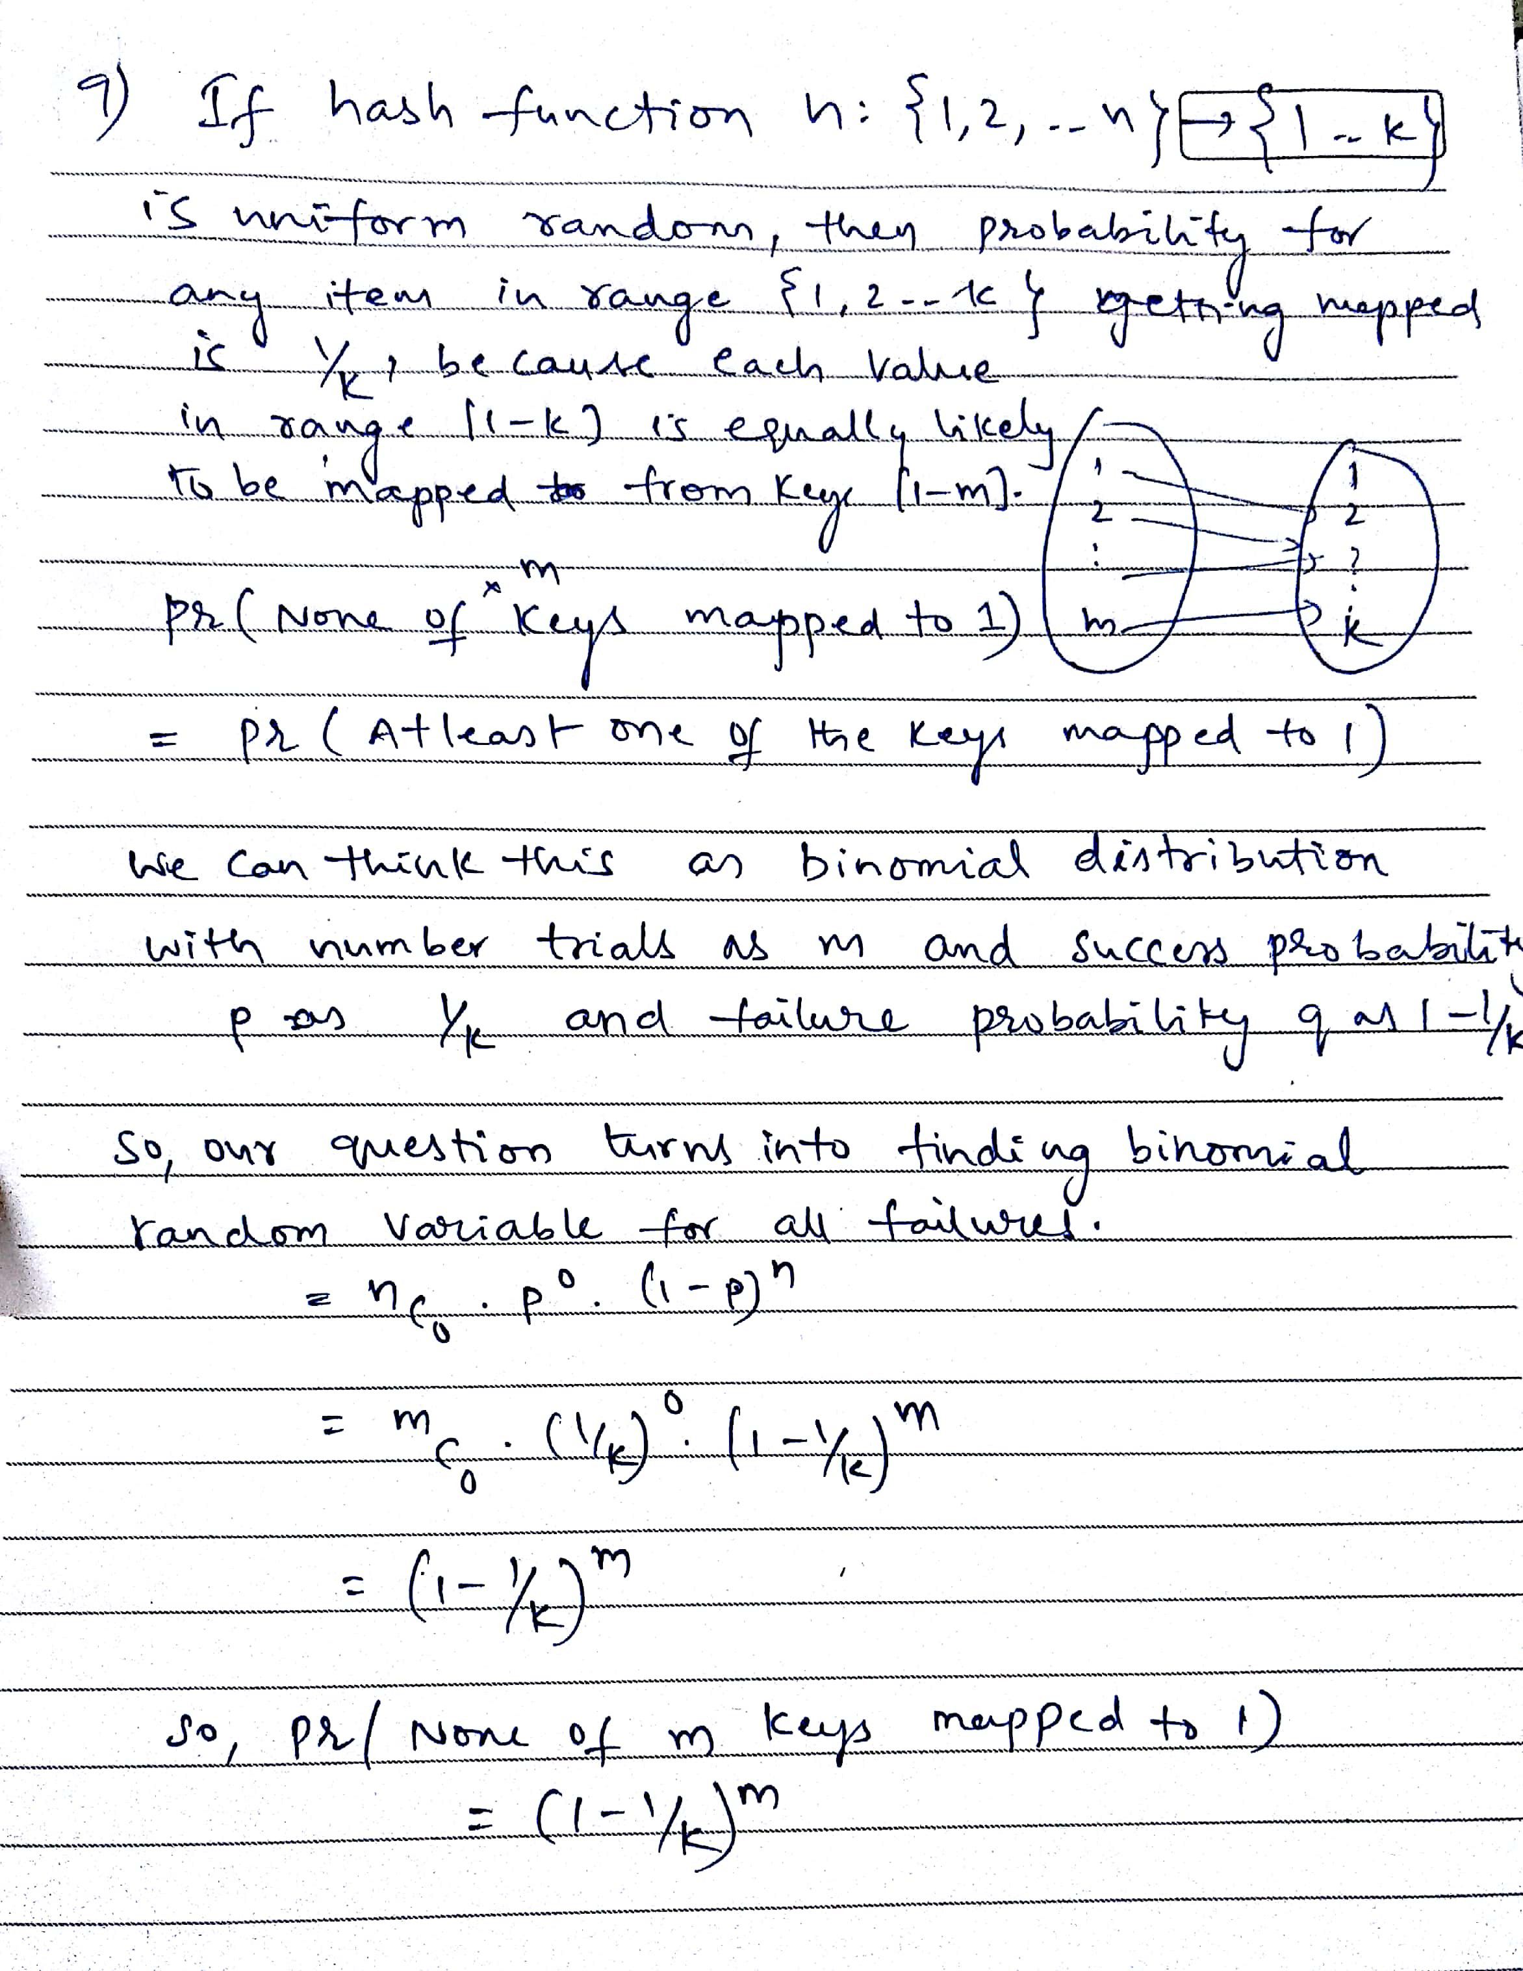

1. Answer attached:

